The laboratory work 3
In this quickstart, you will learn how to:
- Create a cross-platform Xamarin.Forms application.
- Define the user interface for a page using eXtensible Application Markup Language (XAML).
- Interact with XAML user interface elements from code.
The quickstart walks through how to create a cross-platform Xamarin.Forms application, which enables you to enter a note and persist it to device storage. The final application is shown below:
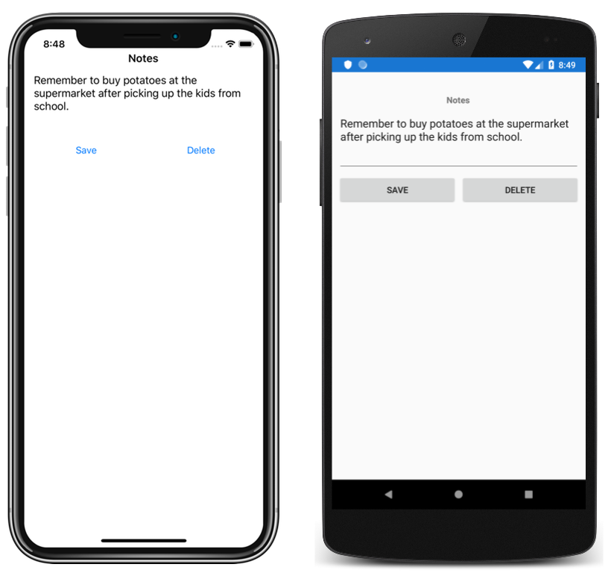

Prerequisites
- Visual Studio 2019 (latest release), with the Mobile development with .NET workload installed.
- Knowledge of C#.
- (optional) A paired Mac to build the application on iOS.
For more information about these prerequisites, see Installing Xamarin.

Get started with Visual Studio 2019
- Launch Visual Studio 2019, and in the start window click Create a new project to create a new project:

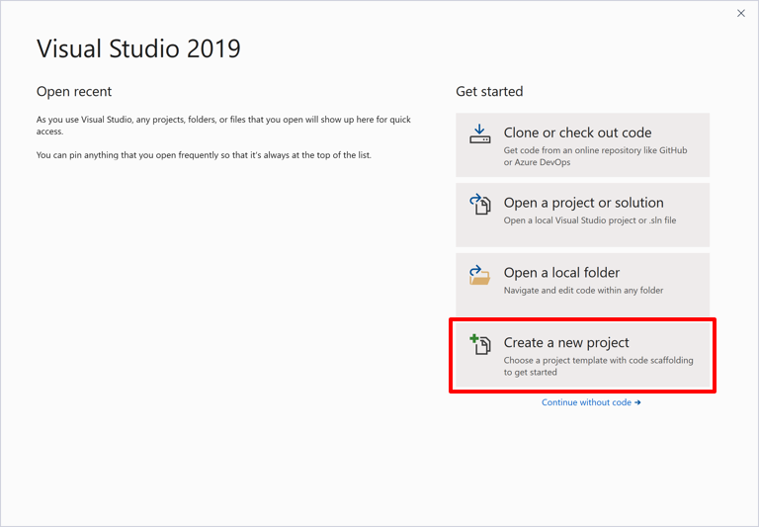
- In the Create a new project window, select Mobile in the Project type drop down, select the Mobile App (Xamarin.Forms) template, and click the Next button:
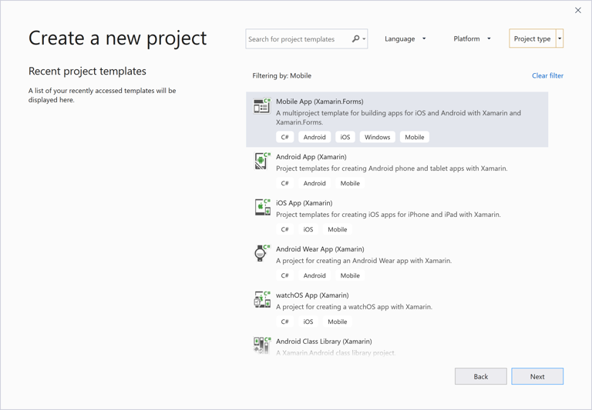
- In the Configure your new project window, set the Project name to Notes, choose a suitable location for the project, and click the Create button:
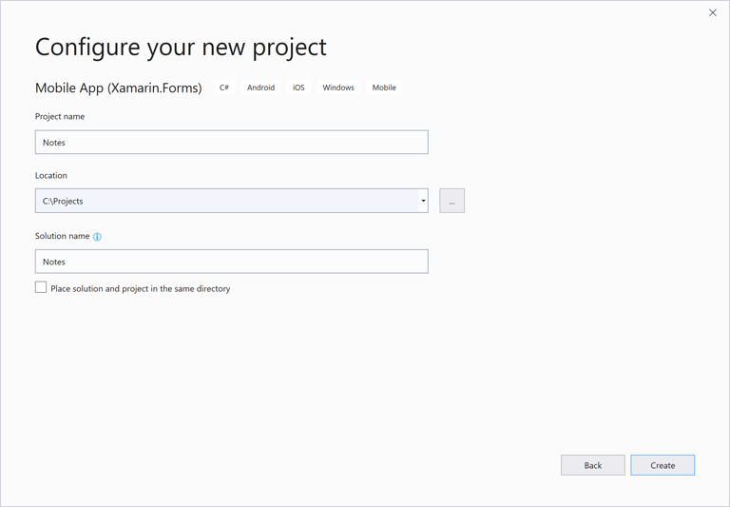
- In the New Cross Platform App dialog, click Blank App, and click the OK button:
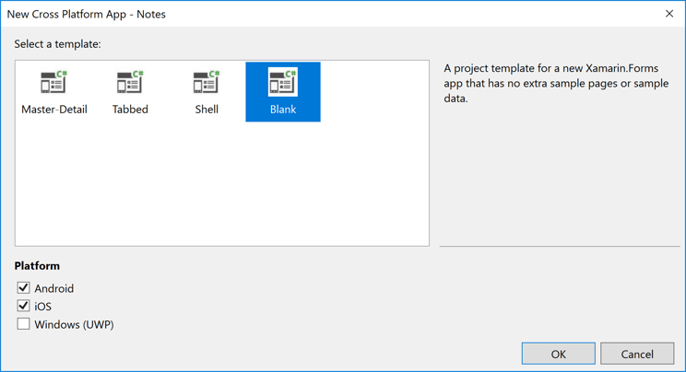
- In Solution Explorer, in the Notes project, double-click MainPage.xaml to open it:
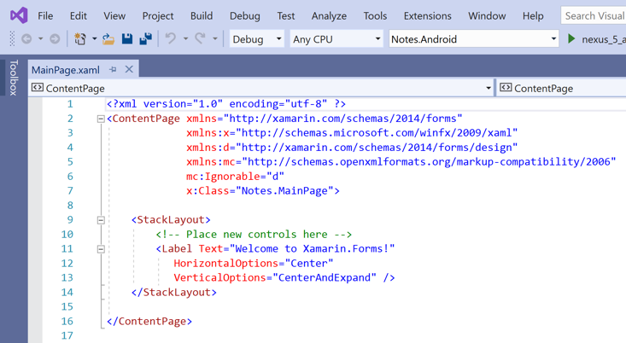
In MainPage.xaml, remove all of the template code and replace it with the following code:
<?xml version="1.0" encoding="utf-8"?>
<ContentPage xmlns="http://xamarin.com/schemas/2014/forms"
xmlns:x="http://schemas.microsoft.com/winfx/2009/xaml"
x:Class="Notes.MainPage">
<StackLayout Margin="10,35,10,10">
<Label Text="Notes"
HorizontalOptions="Center"
FontAttributes="Bold" />
<Editor x:Name="editor"
Placeholder="Enter your note"
HeightRequest="100" />
<Grid>
<Grid.ColumnDefinitions>
<ColumnDefinition Width="*" />
<ColumnDefinition Width="*" />
</Grid.ColumnDefinitions>
<Button Text="Save"
Clicked="OnSaveButtonClicked" />
<Button Grid.Column="1"
Text="Delete"
Clicked="OnDeleteButtonClicked"/>
</Grid>
</StackLayout>
</ContentPage>

This code defines a _fileName field, which references a file named notes.txt that will store note data in the local application data folder for the application. When the page constructor is executed the file is read, if it exists, and displayed in the Editor. When the Save Button is pressed the OnSaveButtonClicked event handler is executed, which saves the content of the Editor to the file. When the Delete Button is pressed the OnDeleteButtonClicked event handler is executed, which deletes the file, provided that it exists, and removes any text from the Editor. For more information about user interaction, see Responding to user interaction in the Xamarin.Forms Quickstart Deep Dive.

Building the quickstart
- In Visual Studio, select the Build > Build Solution menu item (or press F6). The solution will build and a success message will appear in the Visual Studio status bar:
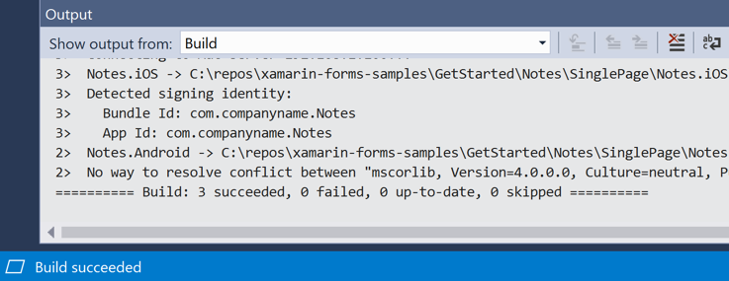
If there are errors, repeat the previous steps and correct any mistakes until the solution builds successfully.
- In the Visual Studio toolbar, press the Start button (the triangular button that resembles a Play button) to launch the application in your chosen Android emulator:
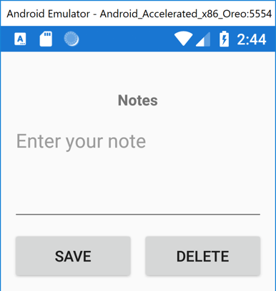
Enter a note and press the Save button.
In the Visual Studio toolbar, right-click on the Notes.iOS project, and select Set as StartUp Project.
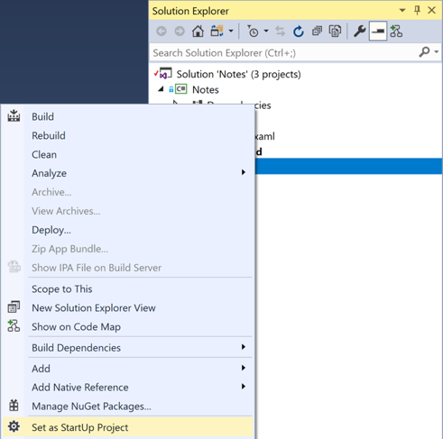
- In the Visual Studio toolbar, press the Start button (the triangular button that resembles a Play button) to launch the application in your chosen iOS remote simulator:
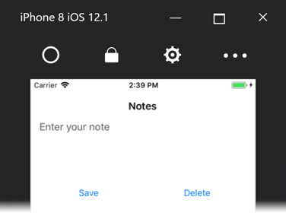
Enter a note and press the Save button.

